Autumn 2022

Dmitry Semenov

[dsemenov@uef.fi](mailto:dsemenov@uef.fi)

+358-50-3043941

**Tasks #1. Colab/Python and spectral files.**

Open spectral images from your measurement session. Open the spectral .raw file of images marked with red check mark. Do it as we did on lectures in Colab using data from respective .hdr file.

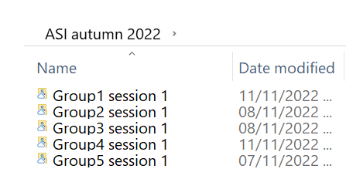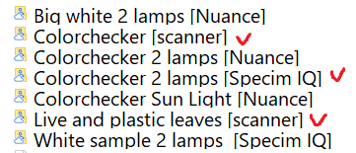

Plot 1) Gray scale preview, 2) RGB preview, 3) Plot pair of spectra in one plot

**Tasks #2. Open ENVI from Japanese spectral camera**

This Japanese spectral camera does not have header file. About camera is known that sensor 1280x1024 and data type is uint16. The number of bands is not known. But it is known that it is ENVI format. Try to open it in Colab.

Share with you ENVI: colorChecker.nh7, ho header

**Hint:** guess the number of bands based on known parameters and file size. **Size in bytes = 1280 x 1024 x <bands =** ?>, where data type is uint16. Read the data size and find the number of bands. You should get Colorchecker image.

**Tasks #3. Open ENVI from other byte order**

This camera has different byte order parameter. Open image and make preview.

Shared with you: Image of coin (Senop camera)

**HSI_snapshot__20212101144836.dat**

**HSI_snapshot__20212101144836.hdr**

**Hint:** Consider data type '>u2'. You may google about it. You should get an image of a coin.

**Tasks #4. Save ENVI spectral image with interleave = bil/bip**

Take the spectral image: SUMMER SCHOOL 2021_\Lectures+Exercises\LectureExercise #5, Freelook and bmp\Colorchecker 121 ms (for Freelook demo)capture/Colorchecker.raw

Load it with Colab. Modify the spectral cube so that you could save it with **interleave = bip**. Saved the new spectral cube as an ENVI spectral file. Manually modify .hdr header-file with the interleave = bip.

**----- header file -----**

**ENVI**

**samples = …**

**lines = …**

**bands = …**

**header offset = 0**

**file type = ENVI**

**data type = …**

**interleave = bil 🡪 bip**

**byte order = 0**

**-----------------------**

Try to open it in Freelook viewer. If everything is correct then you can see preview in Freelook.

**Hints:**

1. ENVI format details:

<https://www.l3harrisgeospatial.com/docs/ENVIImageFiles.html>

<https://www.l3harrisgeospatial.com/docs/enviheaderfiles.html>

1. **Hint: use numpy.rot90**

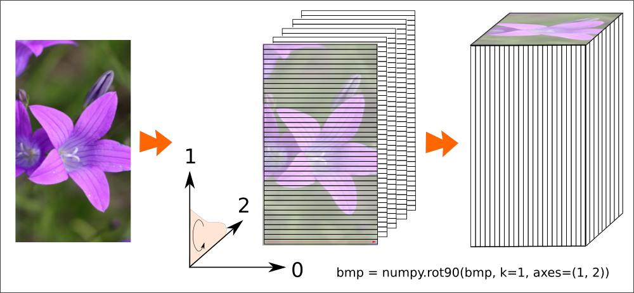

1. After rotation change in header file BIL to BIP